**CSS EXPERIMENT 6**

*CAPTURE ICMP, TCP, AND HTTP PACKETS IN PROMISCUOUS MODE*

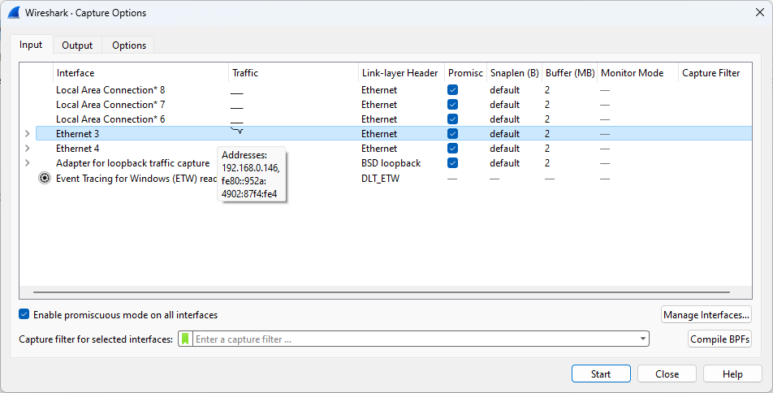

1. ICMP

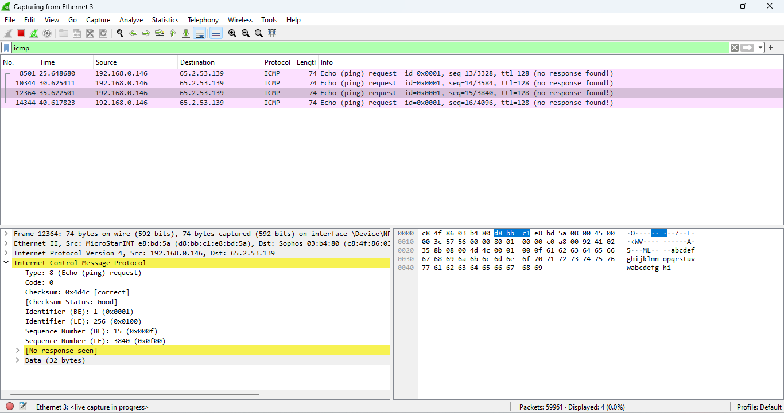

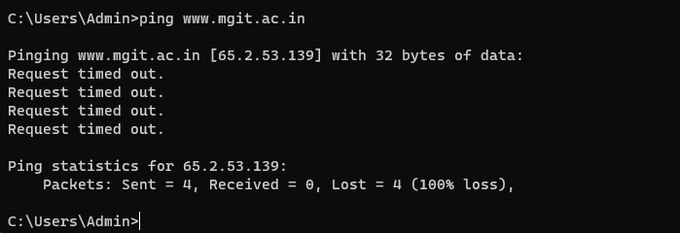

1. TCP

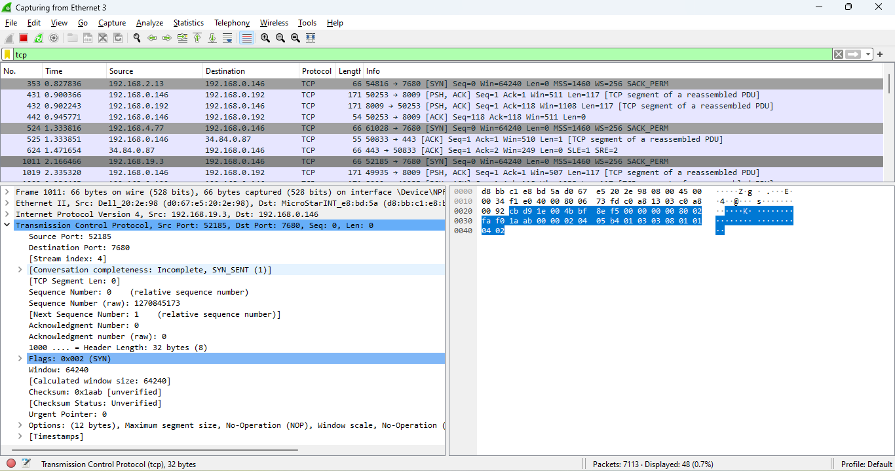

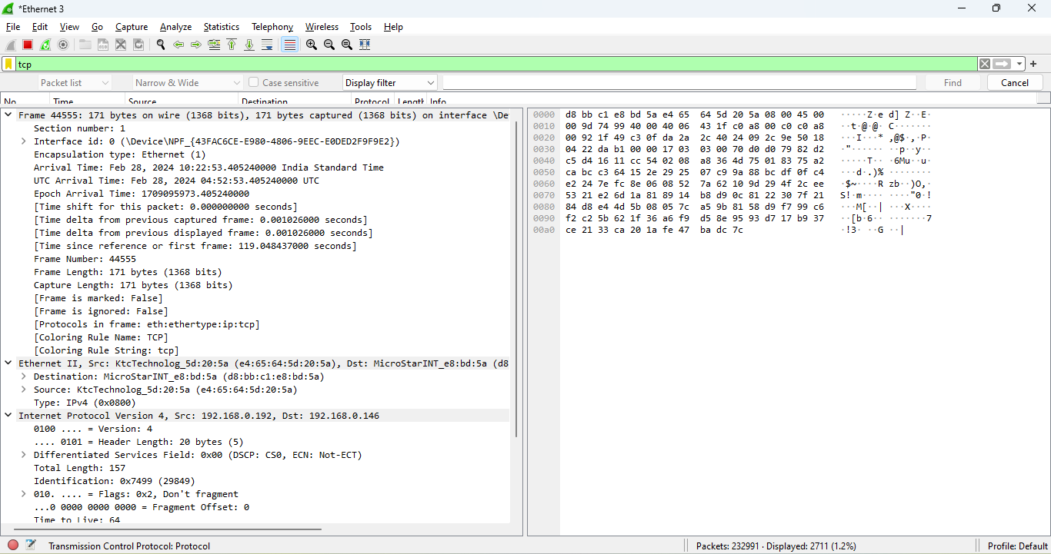

1. HTTP

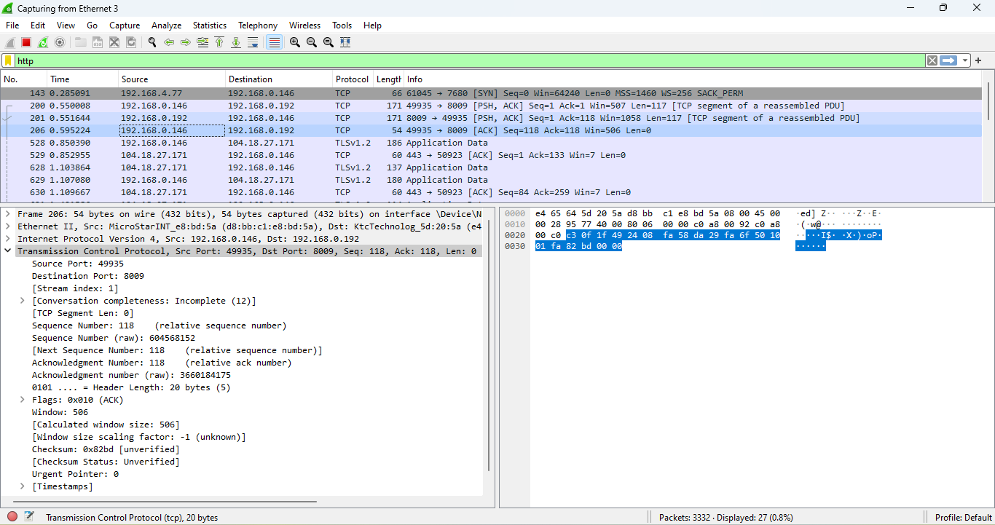

1. ARP

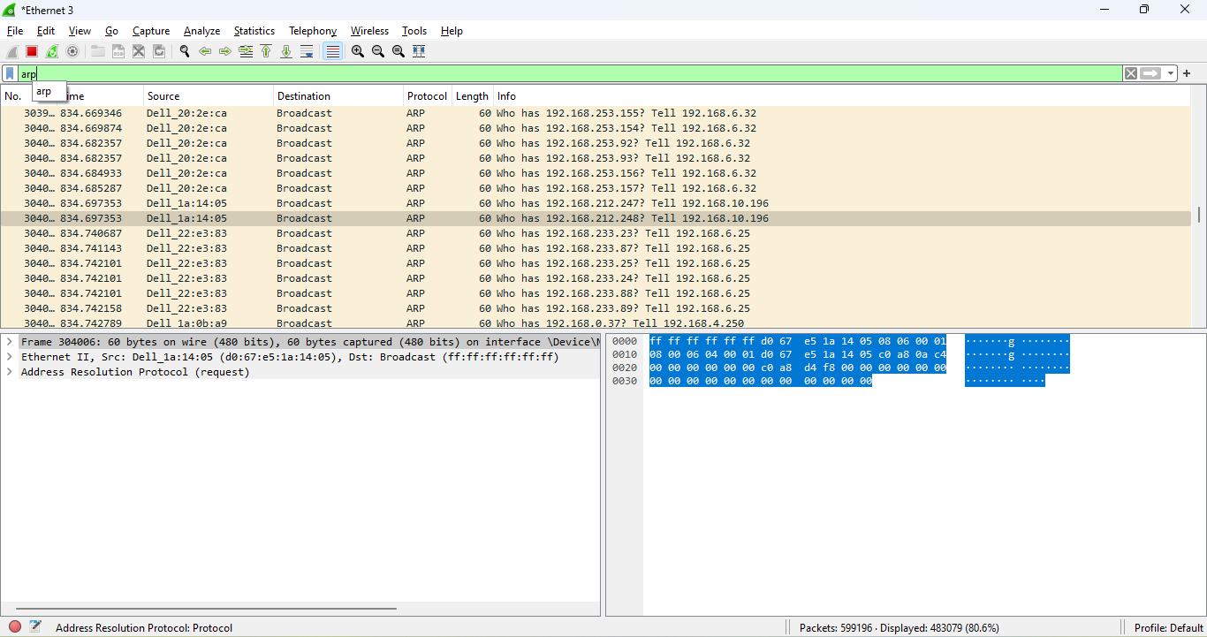

1. UDP

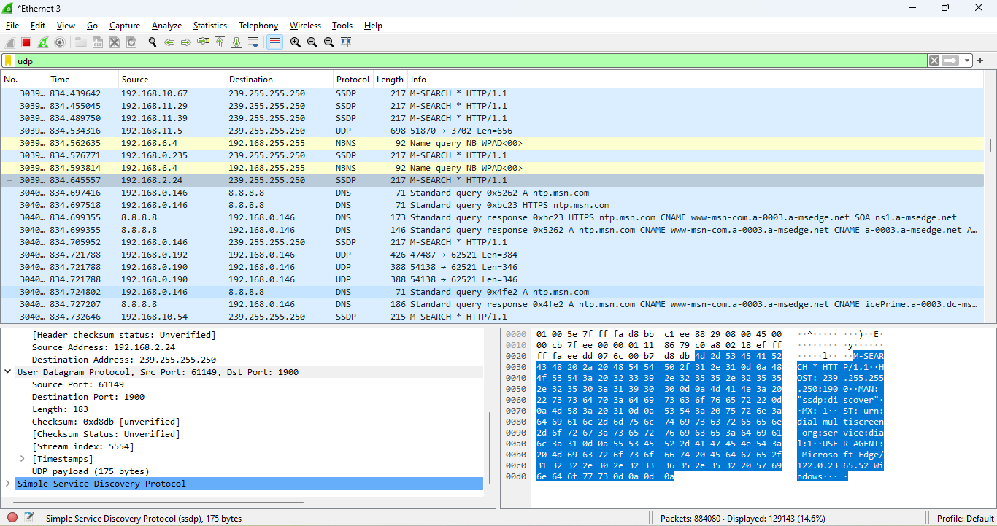

*EXPLORE HOW THE PACKETS CAN BE TRACED BASED ON DIFFERENT FILTERS*

1. Filtering by Source or Destination IP:

ip.src==192.168.4.86

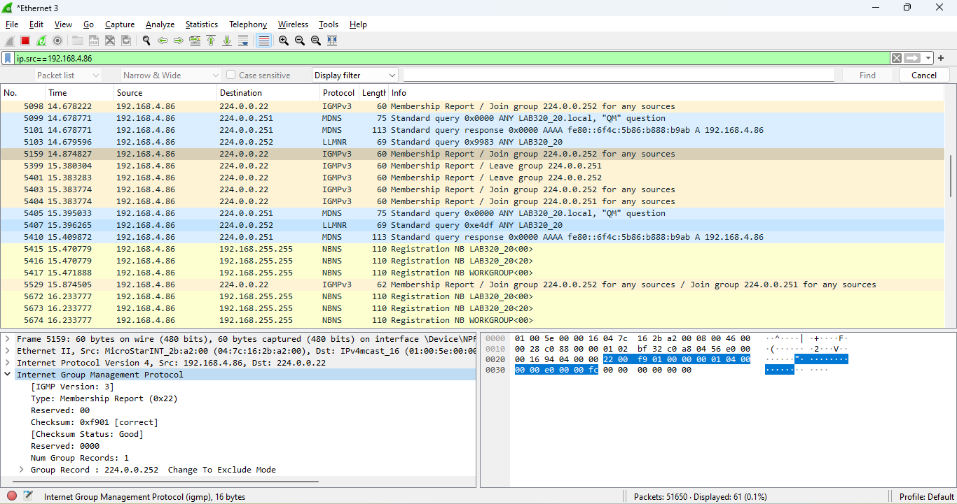

ip.dst==192.168.0.192

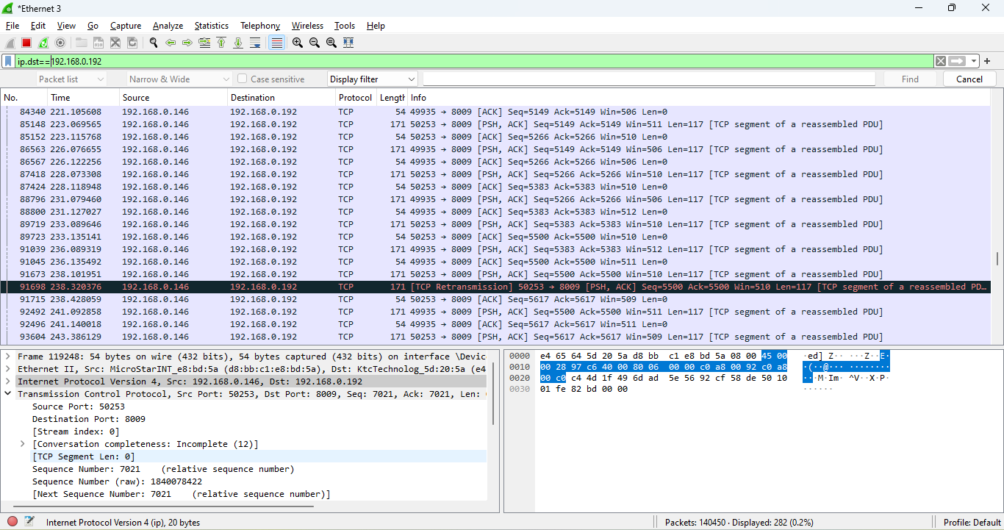

tcp.port==80

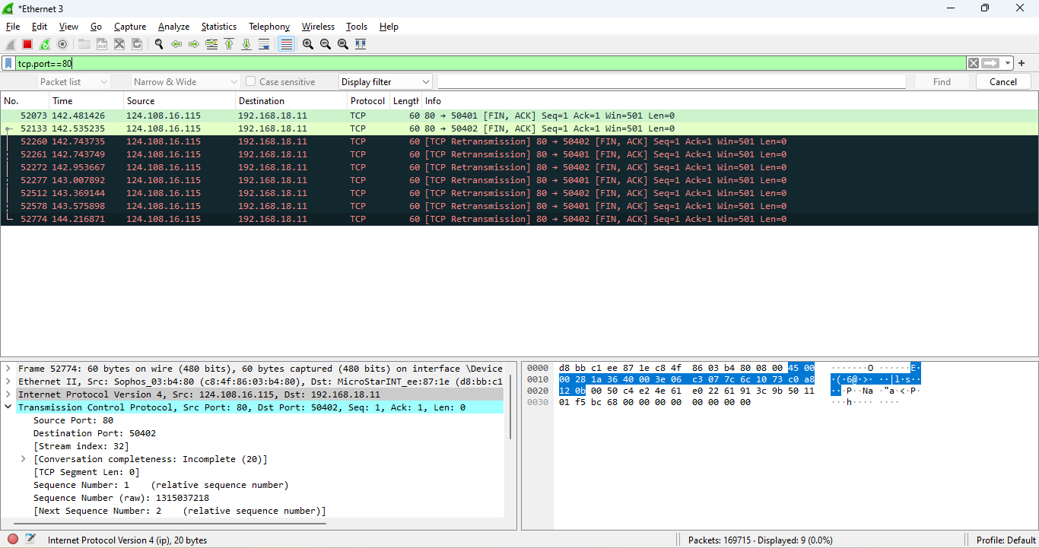

1. Combining Filters

tcp.port==49935 and ip.addr==192.168.0.146

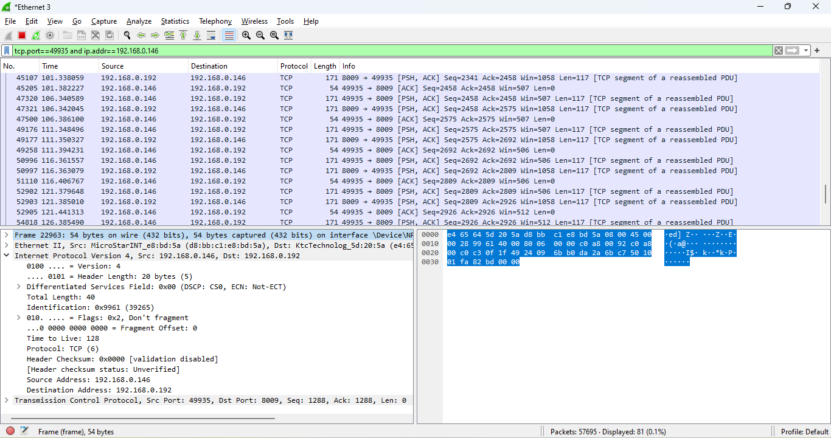

1. Follow TCP Stream

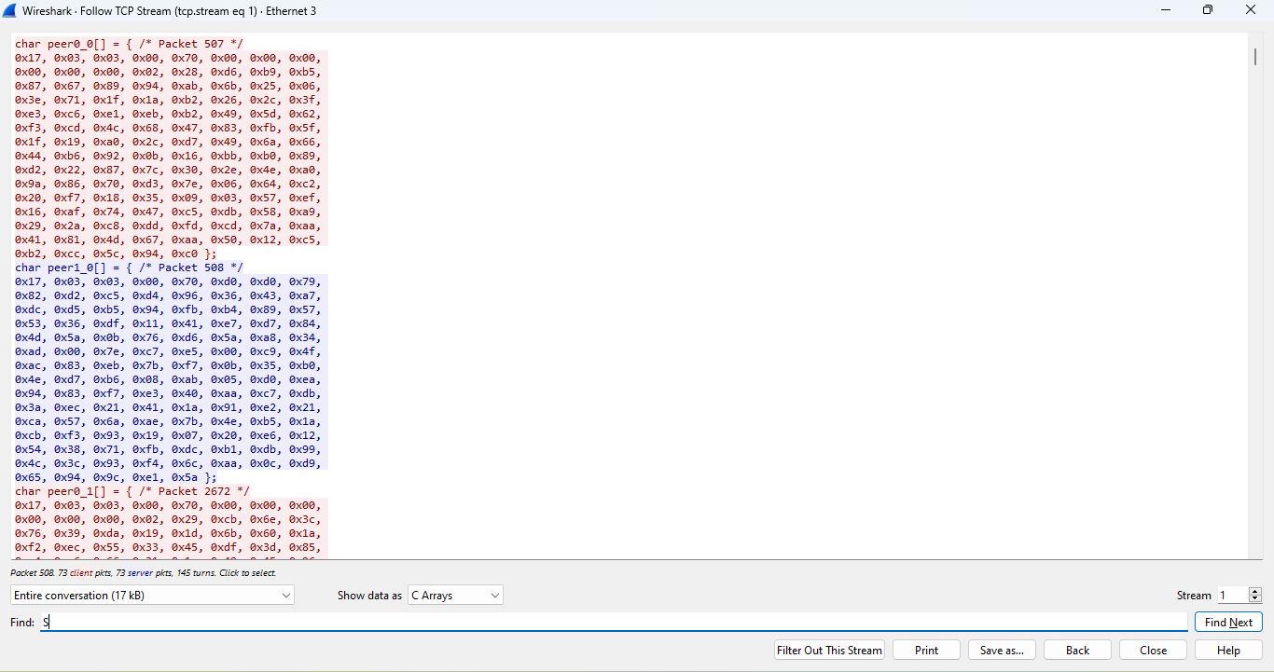

1. Follow UDP Stream

